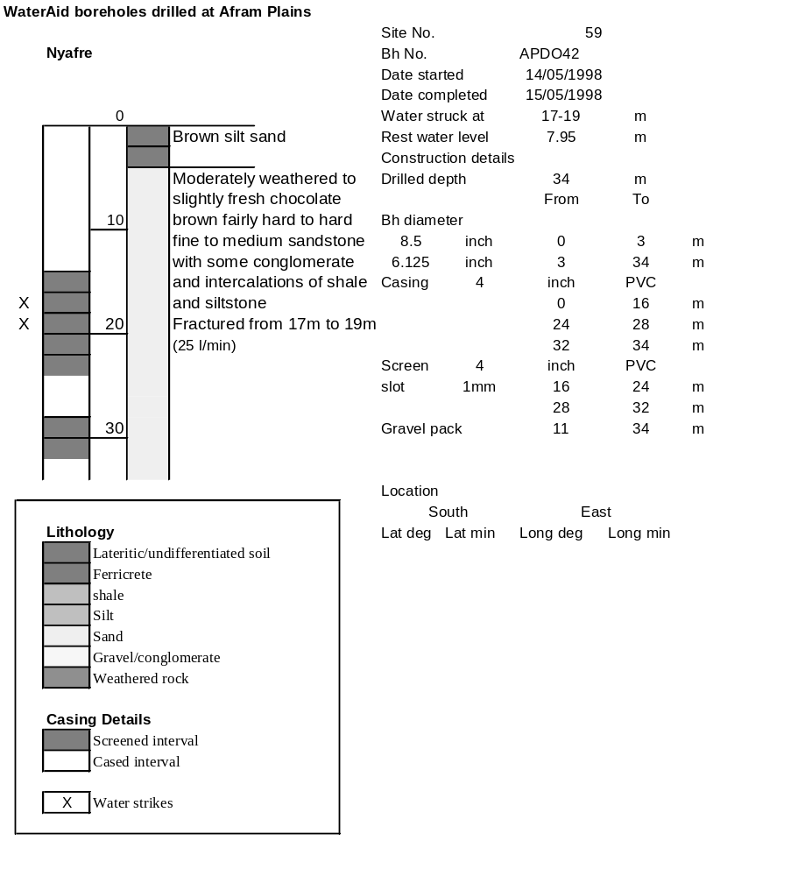

Borehole No. |  | APDO42
Hole No |  | 59 | (9)
Village |  | Nyafre
Date |  | 22/11/1998
Point above GL |  | 0.73 | m
Pump depth |  | 27 | m
SWL |  | 8.68 | m
Start Time |  | 08:50
Drawdown test |  |  |  |  | Recovery Test
time | pwl (m) | Q l/min | dd | sc(q/s) | Time | wl (m) | t/t' | resdd
0.00 | 8.68 | 20.00 | 0.00 |  | 0.00 | 14.59 |  | 5.91
1.00 | 11.50 | 20.00 | 2.82 | 7.09 | 1.00 | 12.45 | 241.00 | 3.77
2.00 | 12.15 | 20.00 | 3.47 | 5.76 | 2.00 | 10.81 | 121.00 | 2.13
3.00 | 12.67 | 20.00 | 3.99 | 5.01 | 3.00 | 9.92 | 81.00 | 1.24
4.00 | 13.06 | 20.00 | 4.38 | 4.57 | 4.00 | 9.50 | 61.00 | 0.82
5.00 | 13.34 | 20.00 | 4.66 | 4.29 | 5.00 | 9.30 | 49.00 | 0.62
6.00 | 13.54 | 20.00 | 4.86 | 4.12 | 6.00 | 9.21 | 41.00 | 0.53
7.00 | 13.66 | 20.00 | 4.98 | 4.02 | 7.00 | 9.17 | 35.29 | 0.49
8.00 | 13.74 | 20.00 | 5.06 | 3.95 | 8.00 | 9.15 | 31.00 | 0.47
9.00 | 13.82 | 20.00 | 5.14 | 3.89 | 9.00 | 9.14 | 27.67 | 0.46
10.00 | 13.89 | 20.00 | 5.21 | 3.84 | 10.00 | 9.13 | 25.00 | 0.45
12.00 | 13.98 | 20.00 | 5.30 | 3.77 | 12.00 | 9.11 | 21.00 | 0.43
14.00 | 14.03 | 20.00 | 5.35 | 3.74 | 14.00 | 9.10 | 18.14 | 0.42
16.00 | 14.05 | 19.00 | 5.37 | 3.54 | 16.00 | 9.09 | 16.00 | 0.41
18.00 | 14.10 | 20.00 | 5.42 | 3.69 | 18.00 | 9.08 | 14.33 | 0.40
20.00 | 14.20 | 20.00 | 5.52 | 3.62 | 20.00 | 9.07 | 13.00 | 0.39
25.00 | 14.48 | 20.00 | 5.80 | 3.45 | 25.00 | 9.05 | 10.60 | 0.37
30.00 | 14.51 | 20.00 | 5.83 | 3.43 | 30.00 | 9.03 | 9.00 | 0.35
35.00 | 14.49 | 20.00 | 5.81 | 3.44 | 35.00 | 9.02 | 7.86 | 0.34
40.00 | 14.50 | 20.00 | 5.82 | 3.44 | 40.00 | 9.01 | 7.00 | 0.33
45.00 | 14.51 | 20.00 | 5.83 | 3.43 | 45.00 | 9.01 | 6.33 | 0.33
50.00 | 14.52 | 20.00 | 5.84 | 3.42 | 50.00 | 9.00 | 5.80 | 0.32
55.00 | 14.52 | 20.00 | 5.84 | 3.42 | 55.00 | 9.00 | 5.36 | 0.32
60.00 | 14.53 | 20.00 | 5.85 | 3.42 | 60.00 | 9.00 | 5.00 | 0.32
70.00 | 14.53 | 20.00 | 5.85 | 3.42 | 70.00 | 8.98 | 4.43 | 0.30
80.00 | 14.54 | 20.00 | 5.86 | 3.41 | 80.00 | 8.97 | 4.00 | 0.29
90.00 | 14.54 | 20.00 | 5.86 | 3.41 | 90.00 | 8.96 | 3.67 | 0.28
100.00 | 14.54 | 20.00 | 5.86 | 3.41 | 100.00 | 8.96 | 3.40 | 0.28
110.00 | 14.54 | 20.00 | 5.86 | 3.41 | 110.00 | 8.95 | 3.18 | 0.27
120.00 | 14.54 | 20.00 | 5.86 | 3.41 | 120.00 | 8.95 | 3.00 | 0.27
130.00 | 14.53 | 20.00 | 5.85 | 3.42
140.00 | 14.53 | 20.00 | 5.85 | 3.42
150.00 | 14.54 | 20.00 | 5.86 | 3.41
160.00 | 14.54 | 20.00 | 5.86 | 3.41
170.00 | 14.54 | 20.00 | 5.86 | 3.41
180.00 | 14.55 | 20.00 | 5.87 | 3.41
190.00 | 14.56 | 20.00 | 5.88 | 3.40
200.00 | 14.57 | 20.00 | 5.89 | 3.40
210.00 | 14.57 | 20.00 | 5.89 | 3.40
220.00 | 14.58 | 20.00 | 5.90 | 3.39
230.00 | 14.59 | 20.00 | 5.91 | 3.38
240.00 | 14.59 | 20.00 | 5.91 | 3.38

